STATEMENT OF CASE AND GROUNDS OF APPEAL
(against planning authority, Dumfries and Galloway Council’s refusal of proposal; Late Listed Building Consent for the Removal of the Church Bells at Holywood Church, Holywood, DG2 0RH)
Ref. no. 24/1491/LBC, 22 October 2024

Appellants: M Huitson and R Bonde (owners of Holywood Church)
18 November 2024

Contents
1. Introduction 4
2. Background information 4
3. The Site 5
4. The planning application 6
5. Relevant planning history 8
6. Relevant planning policies and guidance 8
7. The Case for the Proposal 8
7.1 The appellants’ argument against the council’s objection 8
7.2 A Comprehensive Understanding - The appellants’ archaeological report 9
7.4 Constraints to an inclusive understanding 10
7.3 Constraints to authoritative authentication of the bells’ provenance 12
7.4 The council’s prejudiced view of the bells, and the reasons for removal 13
7.5 Failure of the council to adhere to overarching heritage policy intent 15
7.6 Security concerns discriminatorily dismissed by the council 17
7.7 Public consultation and objection 19
7.8 Summary 20
8. Appendices 24
8.1 Holywood Church, DG2 0RH 25
8.2 Holywood Church Bells 26
8.3 TABLE A: Appellants’ attempt to have the Council engage with an objective evaluation of the bells and the site. 27

1. Introduction
It is important the Scottish Government's Planning and Environmental Appeals Division (DPEA) is aware of the extraordinary context of the appellants’ planning application, in particular the critical issues surrounding significant Scottish heritage and artefacts of national importance, the planning authority, Dumfries and Galloway Council and their statutory consultee, Historic Environment Scotland (HES), in disagreement with the application, are aware of but omit to address in their objections.
The tenor of both the council’s and HES’ expert opinions, is a subjective denial of what the appellants present as a hugely significant discovery in terms of the provenance of the Holywood Church bells. The bells, subject to planning restrictions, are evidenced to be priceless, unique Knights Templar artefacts, created to hang over a Templar convent, not suited, because of security concerns and constraints to the public enjoyment, to be held in a bell tower of a dilapidated, disused church, but deserved of a high-profile museum, or a facility/keeper suitable to their protection. The bells represent the only significant provenanced Templar artefacts in existence, and as such are of significant international interest.
Neither the council’s officers, nor HES, provide any sound, objective substantiation for their denial of this consideration, choosing to denigrate the appellants’ investigative archaeological report, without any transparent impartial professional evaluation.

2. Background information
The Appellants:
Mark Huitson, of Holywood Church, Dumfries, DG2 0RH, and Rachel Bonde, of 13 Dashwood Square, Newton Stewart, DG8 6EQ, joint owners of Holywood Church.
Site address:
Holywood Church, Holywood, Dumfries, DG2 0RH
The Appellants’ Application:
To seek late listed building consent for the removal of two medieval bells from the church, currently placed in off-site storage, due to the bells’ extraordinary provenance, revealed in qualified research as the only significant provenanced Knights Templar material artefacts in existence, and as such, due to their vulnerability and inherent value, cannot be returned to the church under its current condition or ownership.
Application ref no:
24/1491/LBC
The Council’s objection (22 October 2024):
‘The works (removal of the bells) are contrary to National Planning Framework 4 Policy 7 - Historic Assets and Places, Dumfries and Galloway Council Local Development Plan 2, Policy HE1 - Listed Buildings and related Supplementary Guidance, and the Historic Environment Policy for Scotland (2019) as the removal of the bells, without any intention to keep them in a location associated with the site, has an adverse impact on the fabric, character, special architectural and historic interest of the listed building. It has not been satisfactorily demonstrated that the removal of the two bells is necessary for purposes of either security or safety.’

3. The Site

The Church
Holywood church is a category B listed T-plan church with a central, 3-stage square tower on a long south wall, built 1779, and repaired and renovated 1845 and 1864-5. Situated in the middle of a closed historic graveyard not owned by the appellants, the former ecclesiastical building is no longer in use and has special architectural and historic interest as a major example of an intact later 18th century parish church that retains its plan-form. The church surrounded by fields on four sides, is situated one quarter mile from the epicentre of Holywood village and two hundred metres from the nearest dwelling. The church’s listing includes two bells, taken from Holywood Abbey, that once sat in the same location.

The Bells
The original attestation of the bells’ provenance was made in the first Statistical Account of Scotland (published between 1791-99), by the attending parish minister of Holywood, the Rev. Bryce Johnston; ‘…the present church has two fine toned bells, taken out of the old building [the previous abbey church]; one of which, by an inscription and date on it, appears to have been consecrated by the abbot John WRICH, in the year 1154.’ This testimony was challenged in 1898 by local amateur historian, James Barbour, who cited the name on the bell as ‘John WELCH’, with a date of 1505 present within the inscription. The second bell, not detailed in the First or Second Statistical Accounts, was identified by James Barbour as sponsored by William Kennedy, an early 16th century commendator of Holywood Abbey; conjectured by the armorial and initials ‘VK’ supposed present on the bell.
Barbour’s name hypothesis on the first bell was challenged by inspection in 1911 by an auditor from the Royal Commission on the Ancient and Historical Monuments of Scotland (RCAHMS), as ‘WEICH’ with doubt expressed over the first given name interpretation as ‘John’. With this exception, Barbour’s interpretation was allowed to stand in the 1920 official government record for Holywood church.
Forensic collaborative examination of the bells’ inscription by the appellants in 2020-2022, dismantled with demonstrable evidence, James Barbour’s theory and RCAHMS confirmation of it, restoring in part the original attestation within the First Statistical Account of Scotland. An interpretation, considering every element present on the bells’ inscription, identified the presentation as not, John WRICH, Abbot of Holy Wood, but ‘Jesus, W’ [le] RICH, Father of Holy Wood’. Barbour’s interpretation of the initials on the second bell, as ‘VK’ were, as confirmed by the College of Arms; ‘V LR’, with the armorial present on a confirmed pre-1200 pattern bell, and not affiliated to William Kennedy.

4. The planning application

Background to the planning application
The church was bought by the appellants from its former developer in 2019, who in turn had bought the closed church from the Church of Scotland in 2010, as part of their disposal programme. At the time of purchase by the appellants, the property already had planning permissions to create a three-bedroom dwelling, with all the associated architectural and archaeological surveys and considerations in place. The property was in a dilapidated state internally, with part-stripped plaster and lath walls, two damaged stained-glass windows and its internal ecclesiastical fittings removed. The property had no water or sewage services installed, and beyond some new windows and external doors, had not seen any significant progress in redevelopment.
In April 2020, an application was made by the appellants to the planning authority to allow the bells to be removed from the church tower. The appellants were concerned about the loss of public access to the bells, with the previous developer’s architect offering unsound proposals for public viewing: alterations proposed to the bell tower, including the removal of the louvres (installed in 1864) and replacing them with fixed glazed panels would have had a catastrophic impact on the harmonics of the bell chamber, whilst degrading the atmosphere within, drying out the bell frame to its detriment, and cause the bronze bells to ‘sweat’. Also, removing the louvres, a prominent architectural feature, having significant impact on the local landscape, was deemed unsatisfactory by the appellants. Options for the bells considered at that time included displaying the bells in the church’s nearby hearse house, or the local museum, with any monies raised contributing to the redevelopment of the church.
The appellants subsequently postponed the planning process as it became apparent during the application, the bells had far greater historical significance than first thought, and it was deemed appropriate in terms of security, whilst further study was carried out, to halt any further public consultation.
The reported understanding of the bells (part of the property title) was they were both of 16th century origin, based on an inspection caried out in 1898, which conflicted with the appellants’ insurance assessor’s report, bell engineer, and the appellants own learned assessment, supported by challenges made to that 1898 report in 1920 and again in 2009 by a local campaign to have the bells, identified by the campaign as far older, removed from the church before sale by the Church of Scotland. There were also archaeological remains from the original abbey/church, built onto the church’s hearse house that were neither recorded nor understood.
It became apparent, with monitoring, the property suffered catastrophic humidity levels; in excess of 70% (15% above acceptable safe habitation levels), with a yearly average of 90% (measured throughout 2023/2024). It was clear the problem had existed for decades but had failed to be disclosed by the Church of Scotland, the previous developer’s agents, or the developer himself.
Gathering all available information, historical and archaeological reports, it was confirmed the church, and its surrounding graveyard were built over the subterranean structure of the former abbey complex. Deep-sited voids under the church, filling with water and subject to ground heating caused catastrophic humidity problems throughout the church, with palpable warm air in those areas with restricted ceiling heights. Mechanical dehumidification, as a solution to the problem rather than excavation was considered and rejected, particularly as installation of services required excavation, and it was presumed it was the substantial archaeological complexity between the church and mains water and sewage service fifty metres away that had restricted prior installation. A base line estimate for exploration and remedial work to investigate and preserve the archaeology and carry out ground engineering works were in excess of eight-hundred thousand pounds, making the property redevelopment cost between one and two million pounds, because of the unclear nature and extent of archaeological discovery. Thus, the property became untenable as a house conversion. Without the work, the property is unsustainable for long-term storage, commercial use, or human habitation or occupation.
The bells were identified as 12th century, as originally cited in the First Statistical Account of Scotland. It was following forensic examination of the inscription on the bells, that discovery was made of the sponsor, his legend, and evidence he was a master within a military religious order, making the bells the only extant church bells from a Christian military religious convent in the world, created to hang over a Templar preceptory/infirmary.
Appraisal of the investigation by an antiquities expert from Lyon and Turnbull, Edinburgh, and the immediate beta read of historians, collectors and archeologists, supported the appellants’ understanding that the bells were priceless and unique artefacts, with a projected eight figure Sterling value. A later projected insurance valuation (2023), proffered by an agent for Coutts, of around one hundred-and-forty million (with authoritative authentication), concluded the bells were deemed uninsurable by the appellants.
To facilitate safety and closer accessible inspection of the bells, the bells were lowered from the belfry in 2022, within guidance provided by the Council for the Care of Churches. The bells being stored on site, on the ground floor of the bell tower.
In August 2022, following a sharp increase in after dark incursion onto the cemetery site by groups of youths, and a nearby arson attack on an empty historic property, the bells were removed off-site to secure vaulted storage, whilst the appellants petitioned for institutional authentication of the bells’ extraordinary provenance, or equally, authoritative disavowal, based on objective and scholarly-evidenced argument.
With the redevelopment of the church as a house conversion untenable, due to considerable archaeological issues, constraining any economically viable conversion, an alternative redevelopment plan was required, one purely based around the discovery, only achievable with official recognition of the appellants’ discovery. It was considered future management of the bells would be determined by their significant importance as unique artefacts. Thus, it was considered prudent to keep the bells off-site in secure storage, due to their significant potential asset worth, with a pragmatic consideration the church did not provide a secure environment for the bells without redevelopment appropriate to the bells’ housing.
Following recommendations by Historic Environment Scotland (HES), and the council, that retrospective planning should be sought for late listed building consent for the removal of the church bells, application was made by the appellants, but only when general publication of the find became unavoidable, so the public consultation in any planning consideration was no longer a mitigating factor in maintaining confidentiality of the find.

5. Relevant planning history
- 2013: Change of use and alterations to church (Class 10) to form dwelling house (class 9). Ref. 14/P/3/0348. Granted conditionally.
- 2013: Alterations to former to bring about change of use to dwellinghouse. Ref. 13/P/3/0349. Granted unconditionally (Historic).
- 2020: Removal of two church bells. Ref 20/0050/LBC. Withdrawn.
- 2024: Late listed building consent for the removal of the church bells. Ref. 24/1491/LBC. Application refused.

6. Relevant planning policies and guidance
- National Planning Framework 4, Policy 7 - Historic Assets and Places
- Dumfries and Galloway Council Local Development Plan 2
- Historic Environment Policy for Scotland (2019) HEP1-6 – including Listed Buildings and related Supplementary Guidance.

7. The Case for the Proposal

7.1 The appellants’ argument against the council’s objection
The council’s decision and objection are made in context of only that information the current property listing provides, without any demonstrable impartial qualified evaluation of all the facts and evidence presented by the appellants within their submission, regarding the bells’ extraordinary provenance. The council thus offers a subjective dismissal of all the information leading to an inclusive understanding of the bells and the site in their decision making, within the context of listed building consent; regulation not intended to govern the management of significant priceless and unique historical artefact. The council regard the bells’ provenance only in terms of ‘medieval’ architectural fittings; bells connected to the former abbey, formerly contained with the same site as the existing church. The appellants consider this narrow view, not only subjective, but contrary to the best interests of the sustainability of the church, protection of bells of extraordinary provenance and value, and deprivation of the public’s enjoyment and understanding of the bells and the site, within the principles of National Planning Framework 4, Historic Environment Policy for Scotland, and the council’s Local Development Plan.

7.2 A Comprehensive Understanding - The appellants’ archaeological report
Until the appellants’ research, there only existed conflicting antiquarian opinion concerning the Holywood bells, all without any comprehensive investigation or evidenced research. The abbey site was also without any comprehensive understanding or history, prior to the 15th century. This is confirmed by HES, and the council’s archaeologist.
The appellants’ investigation testifies the bells of Holywood Church were sponsored by William le Riche (~1120 - ~1189), who by his presence in King David I of Scotland’s entourage as a witness to several royal charters, the gift of his father’s Midlothian barony to a unknown beneficiary, most likely a religious order, between 1124 and 1130, and William’s existence as a landholding knight with a legally adopted title exclusively carried by 11th and 12th century secular cleric-knights, while he was concurrently recognised in monastic orders as spiritual head and master of a religious community, dictates he was a previously unrecorded 12th century master of a military-religious holy order. As it is Templars who are recorded surrounding David I of Scotland as his personal retinue sometime between 1128 and 1153, with Templar foundation being centered on Midlothian sometime between 1128 and 1130, logical assumption is William le Riche was a Templar rather than a knight of St John; a lessor military hospitaller order, whose first holdings were in west Lothian. Thus, the bells, both bearing his name, and one, his rank within the order, were created to hang over a Templar convent established at Sacro Nemore (Holy Wood); which consequently confirmed the local understanding of the origins of Holywood Church in the 18th century, as reported by John McCormick in his 1843 work, The Antiquities of Dumfries and its Neighbourhood.
The latest version of the appellants’ archaeological report was the culmination of four thousand hours dedicated to research, crafted into over one hundred-and-twenty thousand words laid out in investigation and illustration, with substantial evidence and compelling circumstance building conclusion, rather than supposition, opinion, or nebulous association and speculation. The report is unanimously considered by an esteemed beta read as a remarkable piece of research that irrefutably dismantles the current accepted view and presents evidence and fact, with a robust singular conclusion that provides the only meritorious understanding of the bells and their association with a religious site in the 12th century. The report represents focused enquiry, from two meticulous individuals working collaboratively with international specialists, bringing forensic and analytical discipline to research, free of partiality or preconception.
The appellants had the skills, capacity and necessity (for insurance purposes) to carry out the study on the bells, and together with scholars, specialists, and the College of Arms, produced an exemplary investigative report, adhering to the best practices of enquiry. One of the appellants holds two degrees archaeology and forensic archaeology, and twelve years teaching experience in those subjects, the other has nearly fifty years in historical enquiry, property conservation, surveying and asset management, and award winning medieval bronze recreative art. Both appellants are respected analysts, current or former senior professionals, and proven practitioners in their fields.
The appellants’ evidence has been tested with the foremost academic-referred scholars; medieval military history academic, Helen Nicholson, recommended to the appellants by Malcolm Barber, recognised as the world’s leading authority on the Templars, and Alice Blackwell, medieval finds specialist, recommended by academic archaeologists, because of her connection to National Museums Scotland (NMS). Consensus with the appellants’ testimony was denied, but the academics’ counterargument was constructed on the subjective dismissal of the appellants’ research without substantiated reasoning, substituting any evaluation of the evidence presented by the appellants with ‘blind’ support for a discredited Victorian theory forming the ‘accepted academic record’, bolstered with the scholars’ own opinions, demonstrably devoid of any verifiable fact, and thus unsupportable in context of contemporary evidence and peer understanding. Both the scholars’ opinions and the appellants’ challenge to that opinion, are included in the archaeological report submitted as part of the planning application.
The appellants’ understanding has been circulated internationally to over three hundred beta readers, history academics and institutions, and is subject to public scrutiny. The appellants’ conclusions remain uncontested by any verifiable counterargument yet is denied and ignored by those who have the eminence to authenticate it or indeed dismantle it with evidenced merit. The applicants stress there is no other evidenced and verifiable understanding of these bells. Current public debate leaves the discovery uncontested, and any academic authentication is denied because of perceived intellectual prejudice, not because of the veracity of the archaeological detail, provenance or conclusion.

7.4 Constraints to an inclusive understanding
The council’s objection: ‘the removal of the bells, without any intention to keep them in a location associated with the site, has an adverse impact on the fabric, character, special architectural and historic interest of the listed building.’, is founded on the present property listing for Holywood Church, ie., ‘Two church bells of medieval date from a former abbey church at this location. One bell has an armorial and initials. The other is inscribed…The church bells, which hung in the former abbey church, are part of the special interest of the building and contribute to an understanding of the earlier ecclesiastical history and development of the site.’
The appellants attest the property listing, as it stands, does not constitute an inclusive understanding of the bells or the site, on which all planning considerations concerning the built historical environment should be made. There are no guidelines or restrictions how that understanding is formed, so any understanding must be judged on merit, not necessarily its source.
‘Decisions affecting any part of the historic environment should be informed by an inclusive understanding of its breadth and cultural significance… knowledge and information about the historic environment is critical to our understanding of our past, present and future… Research, discussion and exchange of ideas can all contribute to our understanding of the historic environment. Understanding will improve when information is made widely available, and everyone has the opportunity to contribute to knowledge of the historic environment.’ (Historic Environment Policy 1)
The appellants challenge the council’s dismissal of the appellants’ evidence contributing to that inclusive understanding, presented in the public domain. The council have not applied any objective and transparent evaluation to its merit, and thus the council’s objection and ignorance conversely presents a palpable risk to the property, the bells and the owners tasked with the bells’ protection and denies public enjoyment of a comprehensive understanding of the site, on which the church stands.

Background to the property listing
The appellants presented their initial investigation carried out between 2020 and 2021 to Historic Environment Scotland (HES) in August 2021, to relist, or delist the bells so the bells had the opportunity to be treated outside the constraints of the property listing and housed more appropriately in consideration of their special interest in terms of ‘artefacts of national importance’. The appellants provided a comprehensive understanding of the bells, over and above the information contained within the current property listing for Holywood Church, tested by the foremost academics.
The appellants petitioned Historic Environment Scotland onwards from 2021, who declined to amend the property listing, as they did not think an alteration to the listed building record was necessary. HES confirmed they had looked at the information the appellants submitted, only in the context of HES policy and process for reviewing a designation, with the key decision-making document for their review of a listing being HES Designation Policy and Selection Guidance. HES confirmed they had extremely limited capacity to review listed building records and update them. This meant that when they did, they focused on whether the record is factually inaccurate. HES were content that the information and research the appellants provided did not contradict the statement in the listed building record that the bells are medieval. HES acknowledged why it was important to the appellants to have a public body engage in detail with the research and dating of the Holywood church bells, however the stated HES formal functions (as set out in Regulatory Framework) did not include a role of this nature.
With HES, not appraising the appellants’ understanding of the site and bells, in context of enhancing the property listing, there is conflict between the appellants’ informed and unchallenged understanding of the bells, in terms of dating, sponsor and extraordinary provenance, and the council’s general understanding of the bells as cited within that property listing, with the council giving subjective preference to the property listing over the appellants’ informed comprehensive understanding, and thus is in conflict with the policy objectives included within the National Planning Network 4, The Historic Environment Policy for Scotland and Dumfries and Galloway Council’s Local Development Plan 2.

Appellants’ research in context of the public domain and record of the Historic Environment
HES, in January 2023, suggested the appellants submitted their report to Canmore archive, the National Record of the Historic Environment, so it could be accessed by the public and be used as part of future debate on the origins of the bells. HES confirmed the archive forms a history of the understanding of the site, rather than something that is edited to reflect a single definitive narrative on its history. Canmore is an archive (Canmore ID 212684), and like the listed building record (LB10209), is neither a comprehensive database of historical reference on a site, nor presents an inclusive understanding of a site’s breadth and cultural significance, nor is an authoritative understanding, but instead is one of many sources of reference only. The appellants’ report is considered a live document, broadcast in the public domain; open to review, revision and inclusion as information comes forward in the course of that circulation, debate and promotion. Despite new information being added as the public present artefact and record taken from the Holywood church site, no new information or debate contests the discovery with any counterevidence. Only when the appellants have terminated their campaign and see the church safely removed from their charge, will the report be closed, and submitted to Canmore for archive. In the meantime, the information is freely available, promoted and accessible to the public.

7.3 Constraints to authoritative authentication of the bells’ provenance

Background
The refusal by a prime expert or institution to authenticate the understanding of an artefact or site, has the drastic consequence of rendering the understanding worthless, in terms of the officially recognised ‘accepted’ record. Even if the owner demonstrates sound provenance, if the prime expert refuses to consider or agree with the attribution, their opinion will make the artefact and site untenable, even if their opinions are unsubstantiated.
Outside finding treasure trove, there is no official mechanism for having potentially far-reaching historical discovery recognised and recorded by the State, unless it comes from a recognised public or academic institution. Consideration by these bodies of any find outside their organisation is voluntary, with no appeal mechanism when those bodies behave in such a way that is evidently dismissive, prejudiced, or unprofessional. The appellants are repeatedly advised by history professionals (including the council’s own museums’ curator), that no leading academic in medieval studies will accept a new historical reveal from non-academics. ‘Only a report written by a regarded scholar will be properly considered, and only then if it does not challenge another academic or a fellow antiquarian’s work. Regardless how monumental, complete, evidenced and compelling the reveal is, no leading academic will agree with it’. This arcane and elitist view has been reported time and time again and tested by the appellants, with over two hundred approaches to international medieval history academics and their institutions. It is a condition begrudgingly accepted and denounced by professional historians, archaeologists, genealogists and even history academics the world over. Even senior history academics, including leading US medieval scholars, sympathetic to the appellants’ plight, and agreeing with the appellants’ discovery, in context of ‘an exemplary investigation’, will not publicly endorse the appellants’ study, due to the peer-censure it would bring.
Regarding the understanding around the bells and their original sponsor, there are unfortunately no experts either within academia or without, as there has been no scholarly focus on either early medieval church bells, nor the bells’ sponsor, nor the nature of his title within 11th and 12th century secular clergy, nor the establishment of the religious military orders in Scotland in the 12th century. The two scholars, referred to the appellants by leading academics as ‘the best’ declared specialists in terms of authentication, may have rejected the appellants’ archaeological report, but failed to dismantle the investigation with any substantiated and verifiable opinion. Thus, with academic and institutional refusal (this includes Historic Environment Scotland and National Museums Scotland) to impartially and diligently consider the appellants’ discovery, regardless if it was made within academia or without, does not invalidate it, only renders the find excluded from general acceptance and untenable in terms of ownership.

7.4 The council’s prejudiced view of the bells, and the reasons for removal
HES’ refusal to amend the property listing, and the council’s adherence to it, does not dismiss the appellants’ testimony, supported with evidence and fact. The council and HES present contempt of the comprehensive understanding provided within the appellants’ planning application, without demonstrating any objective appraisal of the evidence. Therefore, the council presents a subjective objection, without substantiation for their dismissal of the facts presented by the appellants, and as such presents an entirely prejudicial stance to the protection of the site’s special interest.
This contempt of the understanding submitted by the appellants is demonstrated by the council’s Senior Planner, Built Heritage Policy, as a consultee to the planning decision, who despite disqualifying themselves from any competent evaluation of the appellants’ archaeological report, employs ambiguity over the report’s credence, despite no equivocality being presented within the report; ‘the conclusions drawn, inevitably differ between authors and researchers and a debate on the detail will no doubt continue as to which is more valid.’ The presented evidence of provenance had already been tested by the foremost recommended academic specialists, with the report demonstrating their counter-opinion was offered without any verifiable evidence, and thus demonstrably unsupportable. There is no more qualified view available. For the officer to ignore this fact, and to imply uncertainty the report has little credence and was only one of many possible presentations of research, that is or will be available, is entirely misleading. Equally, the council’s archaeological officer dismisses the content of the appellants’ archaeological report and understanding, in a consultative role, without any transparent and comprehensive objective appraisal. Both council officers offer a prejudiced denial of the bells’ intrinsic worth in terms of their notable antiquity, without any objective or professional assessment, and as such present a facile attitude to the bells’ substantial significance, and extreme financial value.
It must be noted HES and the council’s archaeological officer were referred to the appellants in 2021 as first point of contact by leading history and archaeology academics, Scotland’s Treasure Trove Unit (National Museums Scotland), and the Portable Antiquities Scheme (British Museum), to examine and evaluate the archaeology found by the appellants in the course of their research on two bells of which there was previously little historical consensus, situated on ‘a very poorly understood site.’ Despite the appellants’ referral and contact, HES and the council’s archaeological officer have declined to engage with the appellants’ research or appraise the finds, including stonework, in context of evaluation and authentication, or even referred the matter to a third-party for expert review. Particularly pertinent, is the council’s archaeology officer, in his consultative role, accuses the appellants in his report of not reporting the archaeological finds, against statute. The fact presented is the officer making the accusation failed to carry out his remit. This failure to engage with the appellants extends to numerous requests for meetings with officers from HES and the council to discuss the planning constraints, all of which have been denied. Considering the significant nature of the find, this seems injudicious, and the appellants can only presume and speculate why this was the case. It has been repeatedly put before the appellants by history professionals and academics, that the appellants’ research is ignored, not because it lacks merit, but because of the lack of academic standing of the architects of the research, in their consideration of what many consider to be a contentious subject, exposing obvious flaws in the current historical record. Thus, HES and the council have avoided transparent appraisal, because unable to dismantle the research, they do not wish to be seen to agree.
Reluctance of the council to take a pragmatic attitude toward the bells’ safety and the site’s recognition in their planning decision, in context that the bells are the only provenanced Templar material in existence, and the site containing the only remaining Scottish, provenanced Templar-built archaeology, is not a product of examination of the evidence provided, but an entirely discriminatory dismissal because that information does not come from a regarded academic source… ‘Understanding will improve when information is made widely available, and everyone has the opportunity to contribute to knowledge of the historic environment.’ (Historic Environment Policy 1)
HES were directly challenged over their refusal to consider the appellants’ understanding, a key factor in the removal of the bells, via complaint, 30 September 2024. HES’ response illustrated they had not appraised or evaluated the information submitted, in terms of the bells’ reported exceptional provenance; illustrating their contempt for the information provided, beyond the fact confirmation the bells were medieval as per their designation. HES offered no evidenced evaluation of their dismissal of the bells’ unique Templar provenance, confirming, regardless of the bells provenance HES recommendation would remain the same. HES refuted the fact that they failed to understand the significance of the bells, and did not consider they had underplayed their significance in their response.
Whereas the appellants agree in principle the bells should remain with the site (not necessarily the church) because of their nine-hundred-year connection, the practical realities presented by a comprehensive understanding of the bells presents a significant constraint to that principle. The bells’ innate value places them above consideration as ‘architectural fittings’, but priceless artefacts of national and international importance, and so the building that houses them should present an appropriately secure and accessible environment, proportionate to the artefacts they house. This reality in context of Holywood Church, is denied because the appellants are not in a position to develop the church, in terms of cost or capacity, unless the bells and the significance of the site’s archaeology is officially recognised, so the appellants can attract an appropriate developer. The council and HES’ refusal to engage with the appellants’ informed understanding of the site and bells, avoiding any authentication or authoritative disavowal in their dictum the bells should not be removed, is an obstruction to the appellants’ opportunity to foster development of the church, and so intentionally puts both the site and the bells (and owners) at unacceptable risk.

7.5 Failure of the council to adhere to overarching heritage policy intent
The council’s objection: ‘The works (removal of the bells) are contrary to National Planning Framework 4 Policy 7 - Historic Assets and Places, Dumfries and Galloway Council Local Development Plan 2 Policy HE1 - Listed Buildings and related Supplementary Guidance, and the Historic Environment Policy for Scotland (2019) as the removal of the bells, without any intention to keep them in a location associated with the site, has an adverse impact on the fabric, character, special architectural and historic interest of the listed building.’
In context of the proposal, the application of the aforementioned policies by the council has merit if the core principles of those policies are maintained in the first instance. In all cases, the policies dictate any proposal should be accompanied by an understanding of the site. Conversely any objection to that proposal should be accompanied by the same attention to its understanding.
- ‘The site and its setting must first be understood. Both the historic and architectural significance must be assessed and evaluated to allow well-conceived, sensitive and creative proposals.’ (Dumfries and Galloway Council Local Development Plan 2)
- ‘Decisions affecting any part of the historic environment should be informed by an inclusive understanding of its breadth and cultural significance.’ (Historic Environment Policy for Scotland, Policy 1)
- ‘Development proposals with a potentially significant impact on historic assets or places will be accompanied by an assessment which is based on an understanding of the cultural significance of the historic asset and/or place.’ National Framework 4, (Policy 7a), Historic Assets and Places.
Yet, a historical understanding of the origins of bells and by association, the site, presented by the appellants is denied by the council’s refusal to carry out any objective evaluation of that understanding, which in turn would inform any objective decision making. The council and its consultees quote only that part of heritage policy that defends their objection, without consideration of the foundation on which those sub-sets of policy support.
Historic Environment Policy No 1 (HEP1); ‘Decisions affecting any part of the historic environment should be informed by an inclusive understanding of its breadth and cultural significance… knowledge and information about the historic environment is critical to our understanding of our past, present and future… Research, discussion and exchange of ideas can all contribute to our understanding of the historic environment. Understanding will improve when information is made widely available, and everyone has the opportunity to contribute to knowledge of the historic environment.’
Historic Environment Policy No 2 (HEP2); ‘Decisions affecting the historic environment should ensure that its understanding and enjoyment as well as its benefits are secured for present and future generations.’
Historic Environment Policy No 5 (HEP5); ‘Decisions affecting the historic environment should contribute to the sustainable development of communities and places.’
In terms of Policy 7 of the National Planning Framework 4 (NPF4), the policy intent is to protect and enhance historic environment assets and places, and to enable positive change as a catalyst for the regeneration of places. Consequently, redundant or neglected historic buildings should be brought back into sustainable and productive uses, recognising the social, environmental and economic value of the historic environment, to the economy and cultural identity.
Without any demonstrable evaluation being presented by the council, regarding the appellants’ contribution of understanding of the bells and their affiliation to a former Templar convent, over and above their place as former ‘medieval’ fittings in relation to a 18th century-built historic building, it cannot be considered the council have applied the core principle of heritage policies to its planning decisions. The council’s decision that removal of the bells ‘has an adverse impact’, in context of their denial of the bells’ essential value to the understanding of Scottish history is perverse, as denial of the bells’ remarkable provenance, promotes public and community deprivation of the site’s full provenance and education, and ipso facto the enjoyment of the site’s history, removing any tangible benefit to present and future generations, in terms of tourism, revenue and education.
Returning the bells under a general ‘medieval’ understanding, will preserve the physical connection of the bells to the site, but will not produce any sustainable development of the church, nor tangible benefit to the community, in terms of education or income, but instead condemn the bells to be hidden; inaccessible within a disused, part-dilapidated building with the inherent archaeology denying any future development, and so contrary to Scottish government core principles underpinning heritage sustainability and public enjoyment. Furthermore, such a decision by the council to maintain them locked away in private ownership, or away from public scrutiny prevents the bells from being further studied, and linkages being made, which in turn may fill additional current gaps in the historic record, denying appropriate conservation, and perpetuates untruth in the public domain.

Regardless of the council’s decision, it must be made within context of an inclusive understanding of the site and in full consideration of the heritage policies put in place to protect and enhance that heritage. It may well be, after objective evaluation of the appellants’ understanding, the council’s decision to object would remain the same, however the robustness of that objection, as it currently stands, does not exist.

7.6 Security concerns discriminatorily dismissed by the council
The appellants contest the council’s inference, ‘It has not been satisfactorily demonstrated that the removal of the two bells is necessary for purposes of either security or safety’. The appellants’ regard the council’s view as injudicious in context of the information submitted with the appellants’ planning application, and previous testimony made by the appellants to the planning consultees, the Senior Planner, built heritage policy, Dumfries and Galloway Council, and HES.
The council’s judgment is based on a negligence of fact, ie., complete unsubstantiated disregard of the information submitted to the council as part of the appellants’ application, submitted in addition to testimony placed before the council’s planning administration, 19 December 2023 and 25 June 2024. The council’s inference is made without evidence of objective appraisal of the testimony submitted in the context of the bells’ attributions, including a demonstrable connection to a master of the Knights Templar, and as such regarded by their association, priceless; as appraised by antiquities specialists Lyon and Turnbull, Edinburgh.

Context – Value
A medieval church bell, depending on provenance, size, condition, decoration, and age, are valued anywhere between six thousand and one hundred thousand pounds Sterling. Church bells generally have a limited niche market, particularly considering the surfeit as more and more churches close. Supply far exceeds demand. The cost of removal, refurbishment, and relocation means it is often more economical to dispose of redundant churches with bells in place (as is the case of Holywood Church), rather than remove them to be retained, or sold on, or offered as a donation to another church or museum. Indeed, in terms of the appellants’ financial commitment, removing the church bells and maintaining secure specialist-vaulted storage off-site, has already exceeded any projected value ‘medieval’ bells could generate in the current marketplace.
The Holywood bells are quite small, not extraordinarily decorated, and exhibit damage to their cannons. Being around 40cms tall and 40cms in diameter, weighing less than 100kgs, they are relatively portable. They are significant in terms of bell archaeology, as they illustrate the time-line development away from high-waisted or beehive forms to squatter economical shapes in the 12th century, using far less bell metal while still producing comparable harmonic value. But even provenanced to a 12th century ecclesiastical or Scottish lord, the bells have little value outside their connection to the site. The reality is, outside scrap value, church bells have little monetary resale value, or general public interest, and so risk of targeted theft is minimal.
However, it is the bells’ extraordinary provenance (with authoritative authentication) that creates an extraordinary valuation, estimated in the tens of millions of pounds Sterling, with an arbitrary insurance valuation closer to nine figure values. The bells and the site are being presented by the appellants to the public as unique Templar material, with no verifiable scholarly or institutional counterargument to dispute that fact. A lack of official authentication does not diminish potential miscreant attraction; a risk of theft, or the desirability to own unique ‘priceless’ Templar material, nor wanton destruction. These are all very real concerns for the bells’ owners, the appellants.
The council’s unsubstantiated denial of the bells’ provenance does not offer protection. Public debate advised by HES, the council’s museums officer and academics generally, means release of the information of the bells’ existence to the public was unavoidable, and so therefore to mitigate any potential risk to the bells and the site, a public declaration the bells are off-site is maintained, with on-site security deterring petty criminal attention or curiosity, intent on investigating any Templar archaeology contained within the church. This security was increased in May 2024, with the employment of a 24hr security team in preparation for publication but was later retired in August due to funding constraints.
The council’s Senior Planner, Built Heritage Policy, as a consultee to the planning decision, downplays the security risk to the bells; ‘The applicants’ research regarding the bells has drawn attention to them but, unless inadvertently, the interested audience is likely to be academic or generally benevolent. If, following further consideration, the outcome is to keep the bells on site it can be done discreetly and quietly in terms of publicity, unless there is a desire to attract visitors.’ The officer’s opinion is disproportionate to the interest the discovery of the bells’ origins will create, in a subject that has universal popular appeal, with significant numbers of Templar interest groups. It is entirely injudicious to state the bells, and the site will primarily attract only academic interest, or entirely benign enquiry. The officer displays an obtuse view to the artefacts, the evidence provided in an accessible report, even the bells potential as the only significant provenanced Templar artefacts in the world, valued as such, promoted by an uncontested archaeological report. The officer’s comments, published in October 2024, were made while the officer was aware of the fact there was a media campaign running (since June 2024), with a website www.hiddenheritage.info, petition, videos, book publication, fund raising, community consultation and social media postings etc. so the officer’s comments are completely ill-judged. Interest is growing, and with the dissemination of fact, international interest is being expressed in these unique Templar artefacts, with the appellants being invited as guest speakers at the next annual Templar conference in Portugal.
The council, and in particular the Senior Planner, Built Heritage Policy, were advised by letter of the ongoing security situation at Holywood church, 19 December 2023, 25 June 2024, and 13 September 2024; being made aware one of the appellants had remained on vigil outside the church since 2019, with a growing number of after dark incursions onto the closed, public accessible cemetery site, particularly after midnight, with the police involved 11 February 2024, and the employment of a 24-hour security dog team from May to August 2024 to deter any potential vandalism and other miscreant attention; incidences of which were reported to the appellants by the last developer, evidenced by broken stained-glass windows and forced entry, resulting in the developer moving onto the site, partly as deterrent.
The actions of the appellants, and the previous developer, over the last eight years, including providing on-site security to the church; to the detriment of family life, the employment of a 24-hour security team at considerable cost, requesting and receiving police involvement, with their increased attention on the site apparent, the removal of the bells; also with considerable associated cost, does not illustrate the appellants’ lack of prudent concern over the site’s security. A potential threat recognised before June 2024, is now aggravated by necessary promotion of the bells’ exceptional provenance in the public domain and nearby communities. Intelligences from neighbours have included perception there is something still in the church worth protecting, particularly since the appellant’s 24hr-dog security team was employed in May 2024. Since the security team’s removal, through a shortfall in self-funding in August, one of the appellants, remaining on-site to provide security, had cause to challenge, on four separate occasions, groups of youths/men investigating the perimeter of the church, some arriving in a long-wheelbase van, between 11.30 pm and 4 am. Although the site is open to the public, and so no crime was evidenced to be committed, challenged, the groups declined to give any cogent reason for their presence, with abuse offered in one incident.
The actions by the appellants and the previous developer, and the information forwarded to the council, contradict the council’s subjective and injudicious inference that security of the bells is not a concern.

7.7 Public consultation and objection
Only one objection to the proposal was received: From the Architectural Heritage Society of Scotland (AHSS). ‘The hypothetical historical background in no way justifies the action taken [removal of the bells].’ As AHSS is a national charity, and so was not objection by an individual/s, the appellants challenged AHSS’ objection by letter, 26 August 2024, asking to receive AHSS’ critique of the appellants’ investigation and understanding of the bells’ provenance, and the qualification of those in AHSS that made it. A further letter was sent after AHSS failed to respond. AHSS’ return demonstrated AHSS did not carry out any objective appraisal of the information submitted with the appellants’ application, but instead offered entirely unqualified subjective opinion.
The local community (DG2 – 0RH, 0RJ, 0RD, 0RF, 0RG, 0RL), and affected local businesses within a two-mile radius of the church were contacted by letter, 6 June 2024, to involve them in the situation regarding the discovery, the bells, and their removal.
Since publication in June 2024, a significant increase in visitors to the site have been noted by the appellants. Many have approached the appellant on site, interested to engage with the site’s history, signing the petition, and supporting the campaign by buying the book accompanying the appellants’ archaeological report. Included within the visitors, were those who have a prior relationship with the church as former parishioners. All have expressed support for the appellants’ campaign, and the reasons the bells have been removed. All those visiting have no doubt of the discovery, some ex-parishioners confirming their own understanding that the church always had a ‘Templar legacy’. All would like to see the church and surrounding historic graveyard refurbished as a celebration of the site’s history.

7.8 Summary
The appellants accept planning consent is required to remove the bells and recognise the purpose of planning control is to protect the interests of the public, not the interests of the appellants, nor even the bells. Nevertheless, the council should be fair and objective in the decisions they make, and reasons for refusal should therefore be objective and evidence based. Regardless of the outcome of the council’s decision, the appellants should expect that it should be made on an inclusive understanding of the nature of the bells and site, appraised without partiality, governed by the entirety of evidence and facts presented.
However, in their objection to the appellants’ proposal, the council have not demonstrated they have carried out any objective appraisal of the bells’ comprehensive understanding, as presented by the appellants, in determining their decision making. The council have neither authenticated, nor disavowed the appellants’ understanding. Thus, the council’s dismissal of the appellants’ testimony of the bell’s extraordinary provenance and value is entirely subjective, and in the appellants’ view, negligently does not consider the significant harm that refusal will bring over and above removal of the physical connection of bells and church. The church as it stands, is not appropriate to the bells’ security, and the council and HES’ refusal to authoritatively authenticate (or authoritatively disavow) the appellants’ understanding is a significant impediment to developing the church suitable to its found history beneath its floors and in its belfry; development essential to create a suitable housing for bells of extraordinary provenance. In the absence of the church’s development, a new keeper must be found, suitable to the bells’ protection, in full disclosure of the bells’ Templar provenance; provenance that has not been dismantled in any way, by any challenge, yet is denied by the council and Scottish historical governance; authorities that exhibit a distinct lack of due diligence to the owners’ historical charge, only because the research was not conducted from within an academic institution; research that is constructed on the work and involvement of many academics and their evidenced research.
The grounds for refusal the council employs are informed only by the existing listing of Holywood church, as maintained by HES. The listing, in terms of general understanding of the bells is correct, but it does not constitute a complete and ‘inclusive understanding’ as promoted by HEP1 and the Council’s Local Development Plan. The current listing is not formed from a comprehensive understanding of the bells or the site, but a distinct lack of it. HES and the council deny the appellants’ exemplary research, as the only forensic and studied examination of the bells and their connection to the site available, without any providing any demonstrable merit to why objects of extraordinary historical interest should be discounted by the council in its considerations. Both the council and HES use the listing, as it stands, to excuse themselves from engaging with the appellants’ discovery, and instead offer an obtuse bureaucratic decision, condemning priceless artefacts to be retained in a dilapidated church, and so deprive any benefit to the church, the public and Scottish heritage and its economy, contrary to Scotland’s heritage policies.
In context of the Historic Environment Policy of Scotland, National Planning Framework 4, Policy 7, and Dumfries and Galloway Council’s Local Development Plan 2, it would be prudent for the council’s agents to first evaluate, assess and understand the bells’ Templar provenance, (if only so they can discount it with substantive evidence) so that an inclusive and informed understanding of ‘the character, special architectural and historic interest of the listed building’ is achieved, and so a sustainable solution to the church, in line with policy is presented by their actions. Since the tenor of the Historic Environment Policy is to both understand heritage and promote its sustainable future, then the appellants should expect the council and HES as the council’s statutory consultant to objectively evaluate any understanding and evidence presented. Only then, if the council can discount the evidence presented as immaterial to their decision making, should they then apply their objection.

Supplementary consideration
The appellants are on a journey from buying a church they hoped would become their home, denied because of a catalogue of misplay by previous owners and the failure to correctly challenge untested antiquarian theories, into a discovery of monumental proportions, via diligent examination and learning, along a road hindered by obduracy, indifference, discrimination, defamation and prejudice, all to see a discovery delivered to the public for their enjoyment and a comprehensive understanding of our past. This appeal forms a pertinent part of that story.
The appellants understand it is not DPEA’s role to deliberate on circumstances outside the appellants’ application, but instead focus on the planning authority’s decisions, particularly refusals that are clearly subjective. However, the appellants must consider any decisions that arise from planning considerations and appeals that negatively impact on the current deviant circumstances surrounding the appellants’ ownership of built heritage, and their responsibility to foster its future sustainability.
There is a balance to be achieved between the detrimental removal of the bells and ensuring the church’s sustainability, as there is between adherence to planning procedure and a pragmatic application of heritage policy. It is only recognition of the bells’ provenance and their association with the archaeology under the church (not the church itself) that provides any sustainable future for the building. The appellants consider the objection to their planning proposal to be narrow-sighted and negligent, replacing any collaborative protection of the site with owners who understand the site implicitly, with a bureaucratic implementation of only that policy that satisfies the council’s ‘perceived’ obligation. The council’s decision is not formed from an objective understanding of the site, but a prejudiced attitude, excused by the existing incomplete property listing, maintained by HES’ refusal to engage with the appellants’ significantly credible discovery, presumably because that discovery is aberrantly made outside academia, thus sits uncomfortably with HES.
The dismissal of the bells’ provenance without any objective appraisal and solemn consideration, is allowing bureaucracy and biased opinion to upset the benefits a full consideration of the evidence presents, not only for the site, the appellants, the local community, but to Scotland. Returning the bells to a church, without prospects of redevelopment, due to the council’s continued refusal to understand the constraints of the site, only to be hidden from public view in an unsustainable dilapidated building, undeveloped due to misunderstood archaeological issues, does not see public enjoyment of heritage, only an illustration and active promotion of its decline. However, authenticating the legend of the bells and the site, creates opportunity to develop it on the shoulders of a significant interest in Templar history.
There are many who view the Holywood bells as one of the most important discoveries in Scottish history. Indeed, review amongst the appellants’ specialist learned legal advocacy, affirmed the appellants’ sound provenance for their discovery and the deviant state of existing historical governance; ‘a coup for both the appellants and Scotland, but within the context of unravelling an academic and bureaucratic mess’.
The council, HES, NMS and academia have had an opportunity to establish whether the bells are simply architectural historic fittings with a specific connection to a site, or priceless artefacts of national and international importance. They have refused to do so and are taking an obdurate stance to that refusal, presumably for no other reason than a discriminatory attitude towards the architects of the discovery.
It is only the limitations of those who carried out past assessment, and a failure of previous keepers to correctly identify the provenance of the bells, that has resulted in the site being misunderstood in terms of its remarkable origins; a situation the council and HES would willingly perpetuate if not for the appellants’ campaign. There is considerable argument in support that these artefacts should never have been included in the sale of Holywood Church but removed to a national museum, which is perversely denied because historical governance refuses to engage with the evidence of the bells’ origins.
Although sustainability of the church is not the prime consideration of the council’s objection, only maintaining the integrity of the bells’ connection to the site, it is of significant concern to the appellants, who have found themselves in ownership of a church not suitable for their original intent, bought with a reasonable expectation planning approval for a dwelling was in place, via a sound and informed planning proposal. This was not the case. Instead, the appellants have needed to undertake to understand the church’s heritage, an exercise previous keepers had failed to carry out. The appellants have gathered all the information that should have been long ago appraised in relation to the church’s sustainability, but neglected by flaws in historical governance, corrupted by an academic view built on Victorian unresearched opinion, itself a corruption of previous understanding. The property is found to be untenable as a dwelling conversion, due to its misunderstood archaeology, legend and disproportionate cost of refurbishment, against any market value. The council neglect to consider this in their objections and are intent on perpetuating the flaws in historical governance, beyond into an atrocious miscarriage of historical record. Returning the bells to the church under a general ‘medieval’ heading as innate architectural fittings may preserve connection to the site, but it does not promote the church’s sustainability, nor recognise the bell’s extraordinary value as a record of bell archaeology.
The appellants consider it is important to consider the entirety of heritage policy to provide a robust and proper consideration of Holywood Church’s place amongst it. Authentication of the bell’s provenance the appellants demonstrate, provides solution, but without proper consideration and a prejudiced denial of authentication, the church stands as a problem, not only for the appellants, but as further illustration of the dereliction of heritage in south west Scotland.
Pragmatic reality is, without the bell’s provenance being authenticated by either academia, or historical governance, or the council, the property will remain with the appellants undeveloped and unoccupied. The appellants accept they removed the bells off-site without planning approval and so wish to stay on the right side of planning statute, but they must prioritise security of the bells, the church, site and themselves whilst they campaign for authentication. Consequently, it will be authoritative authentication of the site’s understanding that will influence the future of the bells and site, not necessarily planning statute.
The appellants stress they are not seeking to separate ‘medieval’ bells from their intrinsic connection to the church site, but place priceless Templar artefacts, discovered in the course of understanding the heritage they were mis-sold, with a new keeper who can preserve them, and in turn use the significant provenance of the bells, global interest, and the monies they raise to ensure a historic church, with substantial archaeological problems, unsuited for development under its existing planning permissions is sustainable for the future enjoyment of the public.

8. Appendices

8.1 Holywood Church, DG2 0RH

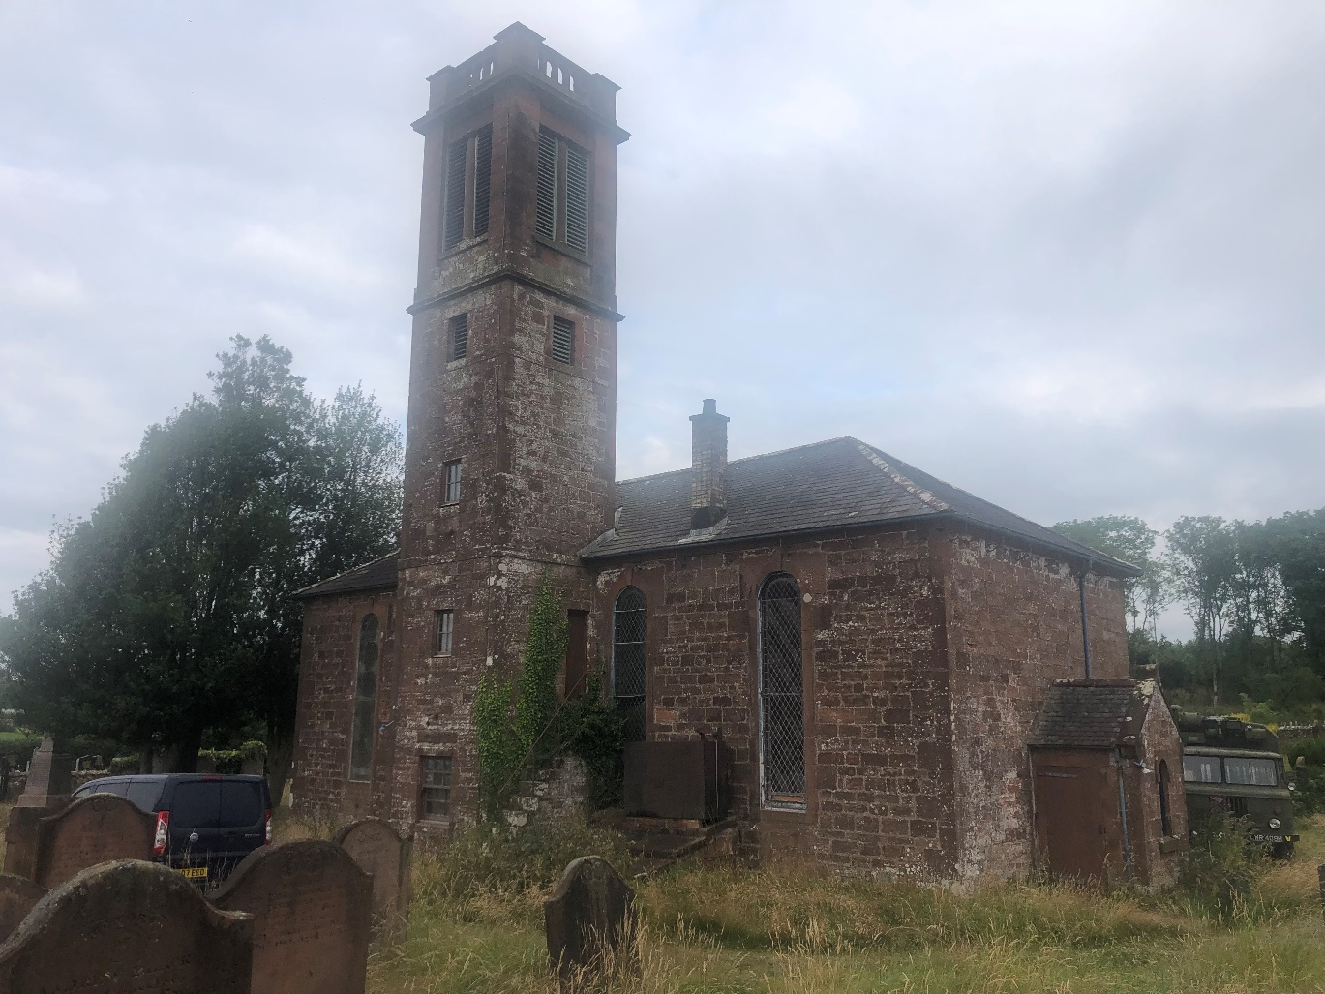
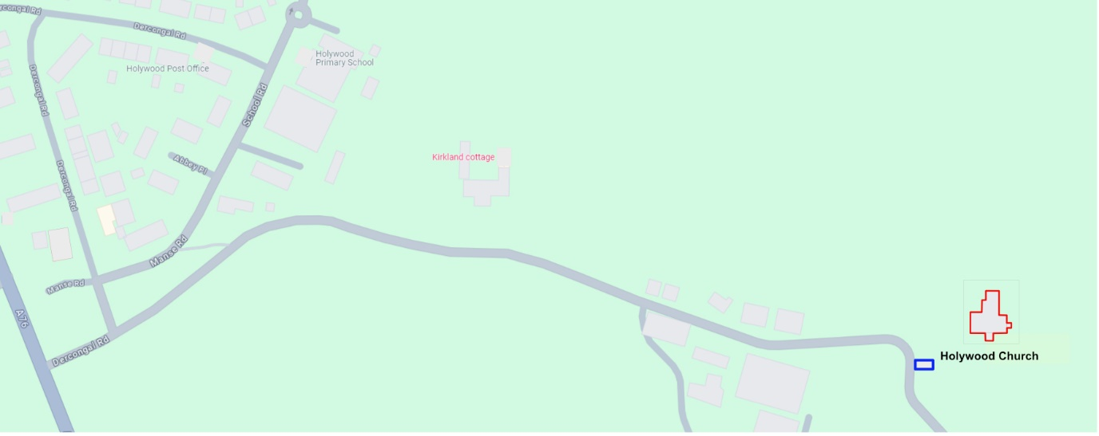

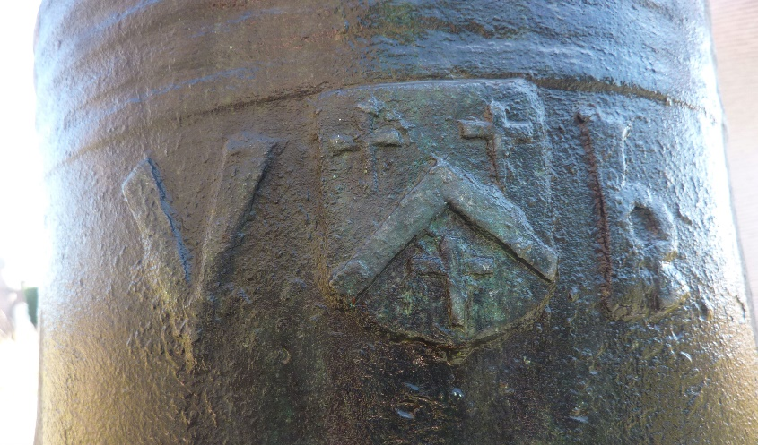
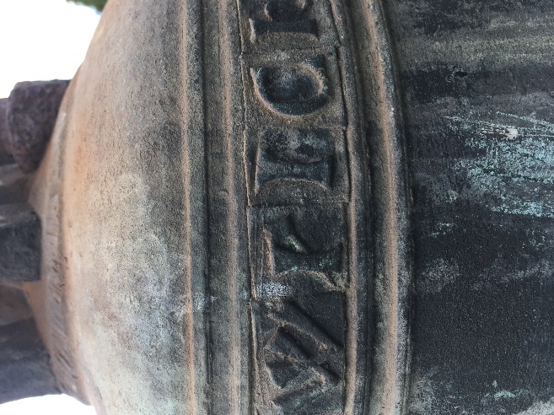
8.2 Holywood Church Bells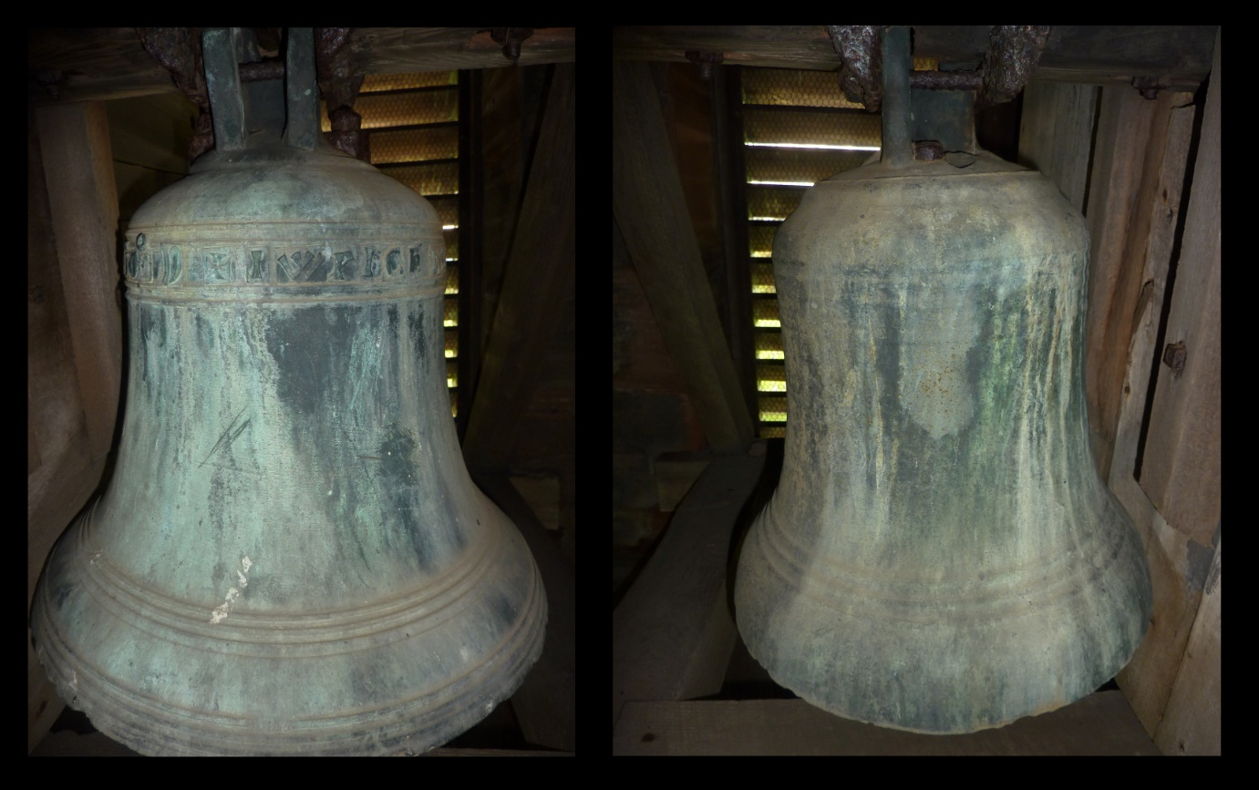

8.3 TABLE A: Appellants’ attempt to have the Council engage with an objective evaluation of the bells and the site.
Date | Context | Response
Historic Environment Scotland (HES)
August 2021 | Contact with HES regarding unrecorded archaeological finds at Holywood Church and a reappraisal of understanding regarding its bells | Confirmation from Alan Rutherford, deputy head of designations, the matter would be looked at, in terms of ‘a very poorly understood site.’
September 2021 | Confirmation first version of appellants’ report, then titled Myth and Mystery, the Bells of Holywood was received | Agreement to interrogate the report.  No feedback, appraisal, evaluation ever returned to the appellants or referral made to any agency or body to assist in the appraisal and confirmation of the appellants’ understanding of the potential discovery of significant artefacts of ‘national importance’.
November 2021 | Application made to redesignate bells within an objective consideration of the appellants; understanding contained within the first edition of the appellants’’ investigative report then entitled report Myth and Mystery, the Bells of Holywood, | HES designations consider the current designation is adequate, with ‘The church bells are appropriately listed as part of the current designation. Application to redesignate bells was this denied.
August 2021 | Discussion regarding appellants’ request to reconsider the bells official understanding. | Rory McDonald, Senior Delegations Officer, agreed our revised understanding held merit but advised it was out of his remit to revise the bells’ listing. Suggested the appellants launch appeal to the decision to maintain the official record despite it being based upon incorrect data.
December 2022 | Petition to HES to engage with the appellants’ understanding, in context of ‘Artefacts of National Significance’ following HES refusal to reconsider the bells listing under a demonstrably erroneous understanding. | HES recognise the flaws in the 1920 The Royal Commission on the Ancient and Historical Monuments of Scotland (RCHAMS) entry under current listing (identifying bells as 16th century), with amendment made recognising the bells as’ medieval’ (1093–1603) with recommendation the appellants’ report is submitted for archive in Canmore, ‘so it can be accessed by the public and be used as part of future debate on the origins of the bells.’
May 2024 | Petition to HES to demonstrate. via their objective appraisal, why HES do not believe the Holywood bells are of any more significant interest than recognition on the property listing as former medieval abbey bells, but also some of the oldest Christian church bells in the world, the only significant Templar artefacts ever identified, sponsored by one of Scotland’s first Knights Templar; objects of significant antiquity and value. | Matter referred to HES complaints procedure
June 2024 | Petition following HES refusal to objectively evaluate the appellants understanding in context to the bells being ‘Artefacts of National Significance’ | HES recognise ‘why it is important to [the appellants] to have a public body engage in detail with the research and dating of the Holywood church bells. But as the lead public body established to investigate, care for and promote Scotland’s historic environment, per its regulatory framework, does not engage with research pertaining to the understanding of Scottish heritage, and does not consider the appellants’ understanding in any way pertinent in the context of reviewing the church’s listing, nor consider alteration to the current listed building record is necessary to meet HES’ own legal requirement. HES referred the appellants to the council as the only body able to agree to a listing change.
September 2024 | Complaint made regarding HES’ recommendation to the council, based on contempt for the appellants’ archaeological report, without any declared, objective reasoning, thus denying a security risk exists or that the bells should receive any special consideration because of innate value.  Appellants cite HES actions as wilful disregard of the fundamental principle of government heritage policy of an ‘inclusive understanding’ of heritage, sustainability and benefit to the public. | HES rejected the complaint, without providing any objective appraisal of the appellants’ understanding, only confirming the disparate understanding of the bells in the antiquarian record before the appellants’ investigation, while reaffirming their application of the government’s heritage policy. recommending architectural fittings, essential to preserve the character of the building are maintained in the building.

Date | Context | Response
The Planning Authority, Dumfries and Galloway Council
8-14 October 2021 | First contact and subsequent meetings with council’s museums officer, Judith Hewitt, requesting a review of the first draft of the appellants’ report | ‘A very impressive and thorough examination of the bells and their significance, comprehensively challenging the existing interpretation of them substantially. There is definite cause to look again at the way that they have been interpreted based on findings. Publication may help to bring forward more information, and opening up a discussion about them can only be a good thing. There is reluctance [from the lead academics] to consider the idea that they may have been wrongly identified -publish and start a debate to see where that leads’
7 August 2021 | Telephone contact with Andrew Nicholson, the council’s archaeologist, referred to the appellants by Treasure Trove Unit (National Museums Scotland) Requested an evaluation of the archaeological finds. | The council officer failed to follow up any inspection of the finds, the site or the report.
19 December 2023 | Letter to the council and local councillors requesting engagement with the discovery | No assistance or engagement offered within a reply and advice that had little relevance to the petition (see footnote 13)
25 June 2024 | Requested pragmatic support of discovery in terms of planning considerations | (See footnote 14) Response took an indifferent approach to the tenor of the find.
13 September  2024 | Letter to planning department expressing concern over the prejudiced attitude of the consultant, HES and the opposition AHSS | No feedback offered
11 October 2024 | Complaint made to council about their officer’s report submitted in the public domain denigrating the appellants’ archaeological report, without professional qualification | Council declined to investigate complaint

Huitson M. & Bonde R. (August 2023) The Templar Bells of Scotland: An investigation into the origins of the bells in a Dumfriesshire church (Version 4.1) [24_1491_LBC-Bell_Report-1530025] https://www.hiddenheritage.info/_files/ugd/66c3ba_bd355640646445088dd6c72ea132c141.pdf
8.3 Table A

